|  |  |
| --- | --- |
|  | **FPT ACADEMY INTERNATIONAL**  **FPT – APTECH COMPUTER EDUCATION** |

**Centre Name: ACE-HCMC-2-FPT.**

**Address: 590 Cach Mang Thang 8, District 3, Ho Chi Minh City, Viet Nam.**

**KHR Smart Study**

**Review Document**

|  |  |  |
| --- | --- | --- |
| **Supervisor:** | Mr. Tran Phuoc Sinh | |
| **Semester:** | 4 | |
| **Batch No:** | T1.2008.A0 | |
| **Group:** | Khareer FPT | |
| **Order:** | **Full name** | **Roll No.** |
| 1. | Nguyễn Ngọc Thiện | Student1275248 |
| 2. | Lê Nguyễn Thành Nhân | Student1277226 |
| 3. | Lê Hữu Tâm | Student1270662 |
| 4. | Phạm Viết Vương | Student1073134 |

June 2022

Table of Contents

Acknowledge 5

Introduction 5

Problem objective 6

Requirement specification 6

Model Development 7

System requirement development 8

Server requirements: 8

Hardware: 8

Software: 8

Client requirement: 9

Hardware: 9

Software 9

Developer Software: 10

Technology: 10

Task Sheet Review 1 11

Use case and Sequence Diagram 13

Use Case Diagram 13

13

Sequence Diagram 15

**REVIEW 1**

Acknowledge

First, we would like to express our gratitude to Aptech Computer Education for providing us with an opportunity to train and compete in software development competition.

Finally, we would send a huge thanks to FPT education for provided us an excellent support to be able to work on the project.

Introduction

Education is a primary necessity and for Parents / Guardians to be updated about their wards, progress is even more important. Students who fail in exams might not reveal their marks to their Parents / Guardians because of fear. Teachers too are overloaded with work, because of which it becomes difficult to remember each child’s academic progress. Also, students too must be kept aware about their score progress and marks required for passing External Exams. A mobile application to track and update all these is a solution.

Problem objective

The objective of this program is a proposed comprehensive mobile application that can be used by students, teachers, and parents/guardians. The proposed mobile application SMART Study will allow various types of users to register and if they are students, they can track the academic progress, access study material through links, receive updates on revision classes, and so on. Students can view and monitor their scores and performance. Teachers can update scores and extra classes information and add resources. With just a click, parents/guardians can keep track of their wards’ performance.

Scope of Project

This software system will be a Mobile Application to be used by students, teachers, and parents/guardians. The mobile application will be designed to keep a track of academic progress and provide users a platform where they can be updated within formation they require.

Requirement specification

Mobile application:  
Employee may view their personal information, working time, leave, job position, …  
Check in and check out by scanning QR code image via mobile app

REQ-01 Home page, Login, Register, Sign out, Feedback, Contact us.

REQ-02 Marking system by Teacher via form for internal tests

REQ-03 Update system by Teacher via form for gradual progress

# Model Development

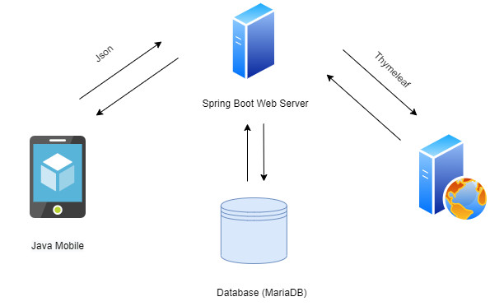

# System requirement development

## Server requirements:

### Hardware:

|  |  |
| --- | --- |
| Component | Requirement |
| CPU | Processor type:  Pentium IV-compatible processor or faster  Processor speed:  Recommended: 2.0 GHz or faster |
| OS | Microsoft Windows XP or higher with IIS |
| Memory (RAM) | RAM:  Minimum: 512 MB  Recommended: 2 GB or more |
| Hard Drive | Free space:  Minimum: 200 MB  Recommended: 50 GB or more  Maximum: Operating system maximum |

### Software:

|  |  |
| --- | --- |
| Component | Requirement |
| Java | Spring Framework |
| RDBMS | My SQL Server |

## Client requirement:

### Hardware:

|  |  |
| --- | --- |
| Component | Requirement |
| CPU | Processor type:  Pentium III-compatible processor or faster  Processor speed:  Recommended: 1.0 GHz or faster |
| OS | All OS(Window ,Linux ,Android ,Mac OS …) |
| Memory (RAM) | RAM:  Minimum: 512 MB  Recommended: 1 GB or more  Maximum: Operating system maximum |
| Hard Drive | Free space:  Minimum: 10 MB |

Software:

|  |  |
| --- | --- |
| Component | Requirement |
| Web Browser | Microsoft Edge, Firefox or Google Chrome |

### Developer Software:

MySQL Server

Git

NetBeans 12 or IntelliJ

### Technology:

Front end: HTML, CSS, Bootstrap, JQUERY, AJAX, VueJS

Back end: Spring framework

Database: Database MySQL

# Task Sheet Review 1

|  |  |  |  |  |  |  |  |
| --- | --- | --- | --- | --- | --- | --- | --- |
| **Project Ref. No.:**  **eP/Human Resource Managerment System/01** | | **Project Title:** | **Activity Plan** **Prepared** **By:** | **Date of Preparation of Activity Plan:** | | | |
| **St.No.** | **Task** | **Actual Start** **Date** | **Actual** **Days** | **Team** **Mate** **Names** | **Status** |
| 1 | Acknowledgement | HR Management System | Nguyen Ngoc Thien | 10/07/2022 | 1 | All member | Completed |
| 2 | Problem Definition | 10/07/2022 | 1 | All member | Completed |
| 3 | Requirement Specification | 10/07/2022 | 1 | All member | Completed |
| 4 | Task sheet review | 10/07/2022 | 1 | All member | Completed |

|  |  |
| --- | --- |
| **Date: 18/03/2021** | |
| Signature of Instructor:  **Mr. Tran Phuoc Sinh** | Signature of Team Leader:  **Nguyen Ngoc Thien** |

**REVIEW 2**

Use case and Sequence Diagram

## Use Case Diagram

# 

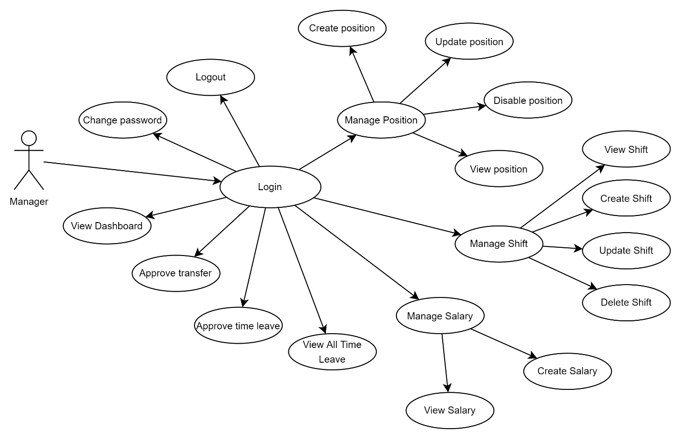

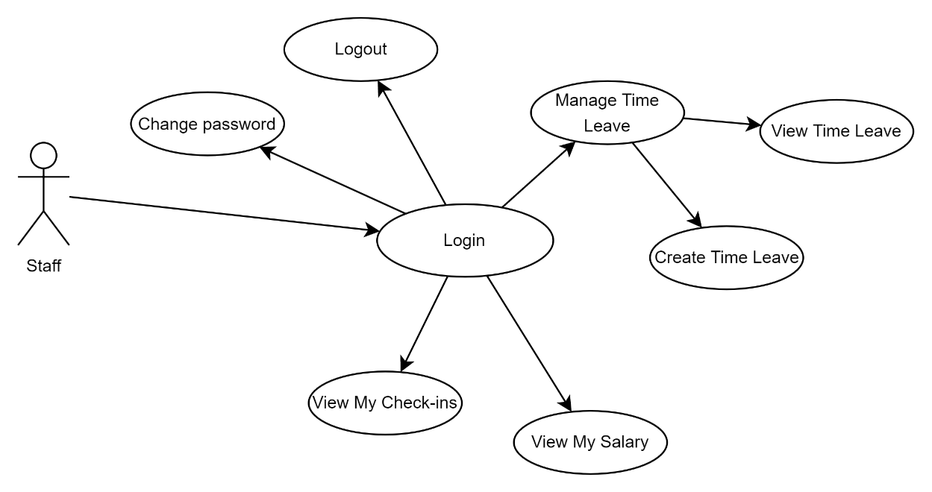

## Sequence Diagram

# Task Sheet Review 2

|  |  |  |  |  |  |  |  |
| --- | --- | --- | --- | --- | --- | --- | --- |
| **Project Ref. No.:**  **eP/ Human Resource Management System /01** | | **Project Title:** | **Activity Plan** **Prepared** **By:** | **Date of Preparation of Activity Plan:** | | | |
| **Sr.No.** | **Task** | **Actual Start** **Date** | **Actual** **Days** | **Team** **Mate** **Names** | **Status** |
| 1 | Architecture & Design of Project | Human Resource Management System | Nguyễn Ngọc Thiện | 14/07/2022 | 1 | All Member | Completed |
| 2 | Use Case Diagram | 14/07/2022 | 2 | Tam | Completed |
| 3 | Sequence Diagram | 14/07/2022 | 2 | All Member | Completed |
| 4 | Entity-Relationship Diagram | 14/07/2022 | 3 | All Member | Completed |
| 5 | Task sheet review | 14/07/2022 | 1 | Thiện | Completed |